

**University Of Balamand**

**Faculty of Engineering**

**Advanced Electric Machines**

**Stationary Magnetically Coupled Circuits   
Transformer Modeling (Open and Short circuit conditions)**

Presented to: Dr. Majed EL-Najjar

Presented by: Kifah Daher  
 Martine Chlela

Date: 24-10-2012

**Abstract:**

This report describes MATLAB/Simulink realization of open-circuit and short-circuit tests of transformer without and with saturation that are performed to identify equivalent circuit parameters. The simulation models are developed to support and enhance Advanced Electric Machines graduate course. The proposed test has been successfully integrated into Advanced Electric Machines course based on the reference book:Krause, P.C. andO. Wasynczuk, *Electromechanical Motion Devices*, MacGraw-Hill, 1989/ Chapter 1 section 1.4 & 1.5 (Example 1-C).

**Introduction:**

In transformers, stationary circuits are magnetically coupled for the purpose of changing the voltage and current levels. Unlike electromechanical devices, circuits in transformers are not in relative motion. Since magnetically couples circuits are necessary in energy conversion, equations which describe their behavior were well established in class as well in book. Taking as example a two winding transformer consist of turns N1 and N2 wounded on a common ferromagnetic core having a large permeability relative to that of the air.

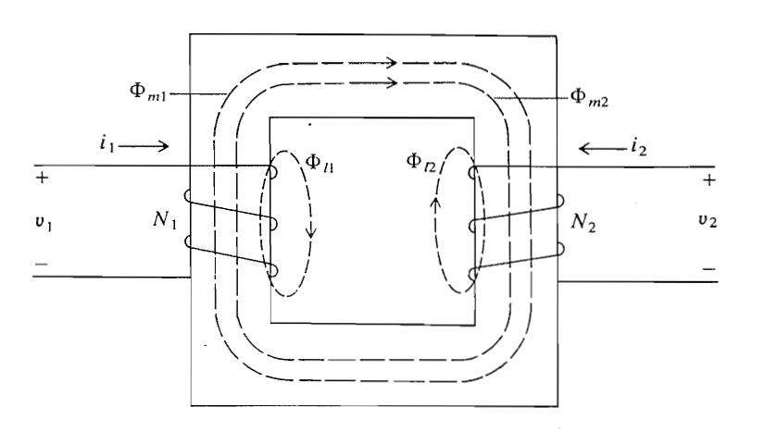

Figure 1: Magnetically coupled circuits

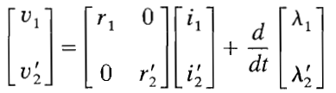Voltage equations and flux linkage equations described and established in book and class suggest the equivalent T circuit representing the two windings transformer.

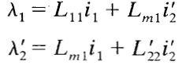

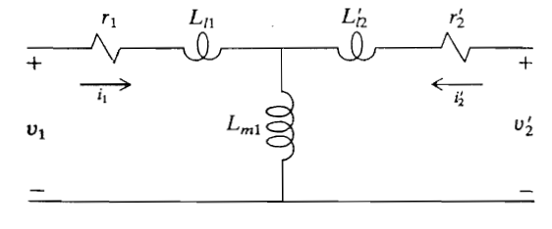

Figure 2: Equivalent T circuit with winding 1 selected as reference

Using the parameters given in example 1C in the book:   
r1 = 6Ω , Ll1 = L’l2 = 13.5 mH, Lm1 = 263.9 mH, Xm1 = 99.5 Ω, r2’ = 5 Ω the transformer was simulated and observed in the open and short circuit characteristics. The variables plotted are λ , v1, i1, v2 and i2’. Two cases were investigated without and with saturation. When considering the saturation of the transformer we have referred to the magnetizing flux linkage and the magnetizing current. The magnetizing flux linkage λ versus (i1+i2’) is the plot representing the saturation characteristics of the transformer which has been implemented as well into MATLAB for computer simulation.

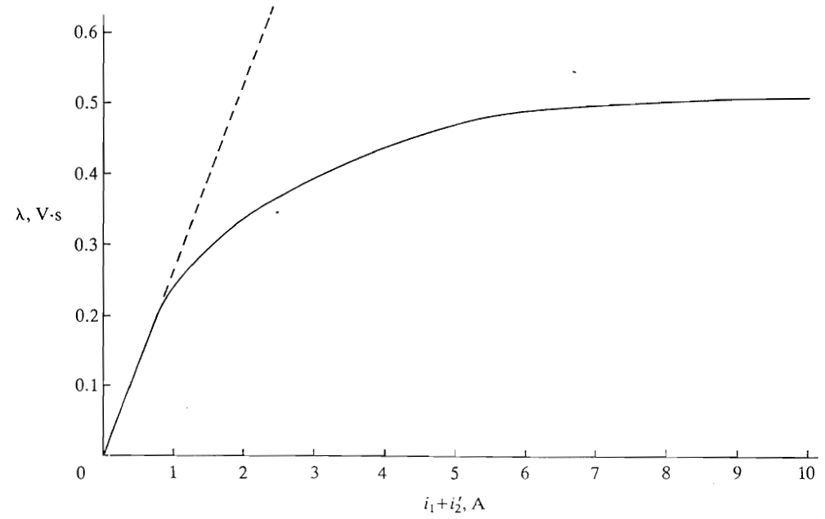

Figure 3: λ versus (i1+i2')

**MATLAB simulation code & results:**

1. Open circuit v1= $\sqrt{2}$ 110 cos (377t) without saturation:

Code:

clear all

clc

t=0:0.0000052:0.2;

v1=sqrt(2)*110*cos(2*pi*60*t);

syms i1 i2 r1 r2 L11 L22 Lm ; % declaring symbolic variables

% declaring variables

r1=6;

r2=5;

Lm=0.2639;

L11=0.0135;

L22=L11;

% solving for i1 using ode23 (differential equation)

di1 = @(t,i1)((((sqrt(2)*110*cos(2*pi*60*t))/(L11+Lm)-(r1*i1)/(L11+Lm)))); % declaring FUNODE to solve differential equation using ODE

[t0,i1] = ode23(di1,[0,0.2],0);

v2=(sqrt(2)*110*cos(2*pi*60*t0))*(Lm/(L11+Lm)) - i1*(r1*((L11+Lm+1)/(L11+Lm)));

i2=0; % i2=0 since it is an open circuit model

lambda = (L11+Lm)*i1;

% plotting results, v1, v2 , i1, i2 and lambda

subplot(5,1,1),plot(t,v1)

title('TRANSFORMER MODELING - OPEN CIRCUIT [ v1=sqrt(2)110cos(377t) ]')

xlabel('time (s)')

ylabel('v1 (V)')

grid on

subplot(5,1,2),plot(t0,i1)

xlabel('time (s)')

ylabel('i1 (A)')

grid on

subplot(5,1,3),plot(t0,v2,'r')

xlabel('time (s)')

ylabel('v2 (V)')

grid on

subplot(5,1,4),plot(t0,i2,'g')

xlabel('time (s)')

ylabel('i2 (A)')

grid on

subplot(5,1,5),plot(t0,lambda,'k')

xlabel('time (s)')

ylabel('lambda (V.s)')

grid on

Results:



1. Open circuit v1= $\sqrt{2}$ 110 sin (377t) without saturation:

Code:

clear all

clc

t=0:0.0000052:0.2;

v1=sqrt(2)*110*sin(2*pi*60*t);

syms i1 i2 r1 r2 L11 L22 Lm ; % declaring symbolic variables

% declaring variables

r1=6;

r2=5;

Lm=0.2639;

L11=0.0135;

L22=L11;

% solving for i1 using ode23 (differential equation)

di1 = @(t,i1)((((sqrt(2)*110*sin(2*pi*60*t))/(L11+Lm)-(r1*i1)/(L11+Lm)))); % declaring FUNODE to solve differential equation using ODE

[t0,i1] = ode23(di1,[0,0.2],0);

v2=(sqrt(2)*110*sin(2*pi*60*t0))*(Lm/(L11+Lm)) - i1*(r1*((L11+Lm+1)/(L11+Lm)));

i2=0; % i2=0 since it is an open circuit model

lambda = (L11+Lm)*i1;

% plotting results, v1, v2 , i1, i2 and lambda

subplot(5,1,1),plot(t,v1)

title('TRANSFORMER MODELING - OPEN CIRCUIT [ v1=sqrt(2)110sin(377t) ]')

xlabel('time (s)')

ylabel('v1 (V)')

grid on

subplot(5,1,2),plot(t0,i1)

xlabel('time (s)')

ylabel('i1 (A)')

grid on

subplot(5,1,3),plot(t0,v2,'r')

xlabel('time (s)')

ylabel('v2 (V)')

grid on

subplot(5,1,4),plot(t0,i2,'g')

xlabel('time (s)')

ylabel('i2 (A)')

grid on

subplot(5,1,5),plot(t0,lambda,'k')

xlabel('time (s)')

ylabel('lambda (V.s)')

grid on

Results:



1. Short circuit v1= $\sqrt{2}$ 110 cos (377t) without saturation:

Code:

clear all

clc

t=0:0.0000052:0.2;

v1=sqrt(2)*110*cos(2*pi*60*t);

syms i1 i2 r1 r2 L11 L22 Lm ; % declaring symbolic variables

% declaring variables

r1=6;

r2=5;

Lm=0.2639;

L11=0.0135;

L22=L11;

% solving for i1 using ode23 (differential equation)

di1 = @(t,i1)((1/L11)*(sqrt(2)*110*cos(2*pi*60*t)-r1*i1)); % declaring FUNODE to solve differential equation using ODE

[t0,i1] = ode23(di1,[0,0.2],0);

v2=0; % v2=0 because short circuit test at secondary

i2=-i1; % assumption i2=-i1

lambda=L11*i1;

% plotting results, v1, v2 , i1, i2 and lambda

subplot(5,1,1),plot(t,v1)

title('TRANSFORMER MODELING - SHORT CIRCUIT [ v1=sqrt(2)110cos(377t) ]')

xlabel('time (s)')

ylabel('v1 (V)')

grid on

subplot(5,1,2),plot(t0,i1)

xlabel('time (s)')

ylabel('i1 (A)')

grid on

subplot(5,1,3),plot(t0,v2,'r')

xlabel('time (s)')

ylabel('v2 (V)')

grid on

subplot(5,1,4),plot(t0,i2,'g')

xlabel('time (s)')

ylabel('i2 (A)')

grid on

subplot(5,1,5),plot(t0,lambda,'k')

xlabel('time (s)')

ylabel('lambda (V.s)')

grid on

% zooming on lambda to see transient

figure

plot(t0,lambda),

title('Zooming on Lambda')

grid on

axis([0 0.1 -0.42 0.42])

Results:



1. Short circuit v1= $\sqrt{2}$ 110 sin (377t) without saturation:

Code:

clear all

clc

t=0:0.0000052:0.2;

v1=sqrt(2)*110*sin(2*pi*60*t);

syms i1 i2 r1 r2 L11 L22 Lm ; % declaring symbolic variables

% declaring variables

r1=6;

r2=5;

Lm=0.2639;

L11=0.0135;

L22=L11;

% solving for i1 using ode23 (differential equation)

di1 = @(t,i1)((1/L11)*(sqrt(2)*110*sin(2*pi*60*t)-r1*i1)); % declaring FUNODE to solve differential equation using ODE

[t0,i1] = ode23(di1,[0,0.2],0);

v2=0; % v2=0 because short circuit test at secondary

i2=-i1; % assumption i2=-i1

lambda=L11*i1;

% plotting results, v1, v2 , i1, i2 and lambda

subplot(5,1,1),plot(t,v1)

title('TRANSFORMER MODELLING - SHORT CIRCUIT [ v1=sqrt(2)110sin(377t) ]')

xlabel('time (s)')

ylabel('v1 (V)')

grid on

subplot(5,1,2),plot(t0,i1)

xlabel('time (s)')

ylabel('i1 (A)')

grid on

subplot(5,1,3),plot(t0,v2,'r')

xlabel('time (s)')

ylabel('v2 (V)')

grid on

subplot(5,1,4),plot(t0,i2,'g')

xlabel('time (s)')

ylabel('i2 (A)')

grid on

subplot(5,1,5),plot(t0,lambda,'k')

xlabel('time (s)')

ylabel('lambda (V.s)')

grid on

% zooming on lambda to see transient

figure

plot(t0,lambda),

title('Zooming on Lambda')

grid on

axis([0 0.1 -0.42 0.42])

Results:





1. Open circuit v1= $\sqrt{2}$ 110 sin (377t) with saturation:

Code:

clear all

clc

t=0:0.00052:0.2;

v1=sqrt(2)*110*sin(2*pi*60*t);

syms i1 i2 r1 r2 L11 L22 lambda1 ; % declaring symbolic variables

% inputing values from the plot lambda versus (i1+i2') - lambdam not constant because of saturation effect

lambda=[0;0.1;0.13747;0.19434;0.21635;0.2457;0.28056;0.30624;0.33743;0.37778;0.40897;0.46967;0.464;0.476;0.476;0.476;0.45;0.486];

x1=[0;0.3788;0.5144;0.7165;0.8267;1.0769;1.3778;1.6648;2.1057;2.774;3.4905;4.3649;5.2737;6.1106;7.0475;7.9547;8.4274;9.4806];

p=polyfit(x1,lambda,6); % reconstructing a polynomial fitting the curve

f=polyval(p,x1);

lambdam=vpa(p(1).*i1.^6+p(2).*i1.^5+p(3).*i1.^4+p(4).*i1^3+p(5).*i1^2+p(6).*i1+p(7));% lambdam in plynomial form of six degree

digits(4) % decimal precision

dlambdam=diff(lambdam); % differentiating lambdam

% declaring variables

r1=6;

r2=5;

L11=0.0135;

L22=L11;

% solving for i1 using ode15s (differential equation)

di1=@(t,i1) (((-r1*i1)/(L11+eval(dlambdam)))+((sqrt(2)*110*sin(2*pi*60*t))/(L11+eval(dlambdam))));

[t0,i1] = ode15s(di1,[0.0,0.2],0.0);

i2=0; % i2=0 since short circuit

v2=(((-r1*i1)/(L11+eval(dlambdam)))+((sqrt(2)*110*sin(2*pi*60*t0))/(L11+eval(dlambdam))))*eval(dlambdam);

lambda1=L11*i1+eval(lambdam);

% plotting results, v1, v2 , i1, i2 and lambda

subplot(5,1,1),plot(t,v1)

title('TRANSFORMER MODELING - OPEN CIRCUIT WITH SATURATION [ v1=sqrt(2)110sin(377t) ]')

xlabel('time (s)')

ylabel('v1 (V)')

grid on

subplot(5,1,2),plot(t0,i1)

xlabel('time (s)')

ylabel('i1 (A)')

axis([0 0.2 -15 15])

grid on

subplot(5,1,3),plot(t0,v2,'r')

xlabel('time (s)')

ylabel('v2 (V)')

grid on

subplot(5,1,4),plot(t0,i2,'g')

xlabel('time (s)')

ylabel('i2 (A)')

grid on

subplot(5,1,5),plot(t0,lambda1,'k')

xlabel('time (s)')

ylabel('lambda1 (V.s)')

grid on

Results:



1. Short-circuit v1= $\sqrt{2}$ 110 sin (377t) with saturation case :

In short-circuit condition saturation does not occur (i1 = -i2 => i1+i2’ = 0). The following work proves that.

Code:

clear all

clc

t=0:0.00052:0.2;

v1=sqrt(2)*110*sin(2*pi*60*t);

syms i1 i2 r1 r2 L11 L22 lambda1 ; % declaring symbolic variables

% inputing values from the plot lambda versus (i1+i2') - lambdam not constant because of saturation effect

lambda=[0;0.1;0.13747;0.19434;0.21635;0.2457;0.28056;0.30624;0.33743;0.37778;0.40897;0.46967;0.464;0.476;0.476;0.476;0.45;0.486];

x1=[0;0.3788;0.5144;0.7165;0.8267;1.0769;1.3778;1.6648;2.1057;2.774;3.4905;4.3649;5.2737;6.1106;7.0475;7.9547;8.4274;9.4806];

p=polyfit(x1,lambda,6); % reconstructing a polynomial fitting the curve

f=polyval(p,x1);

i2=-i1;

lambdam=vpa(p(1).*(i1+i2).^6+p(2).*(i1+i2).^5+p(3).*(i1+i2).^4+p(4).*(i1+i2)^3+p(5).*(i1+i2)^2+p(6).*(i1+i2)+p(7));% lambdam in plynomial form of six degree

digits(4) % decimal precision

dlambdam=diff(lambdam); % differentiating lambdam

% declaring variables

r1=6;

r2=5;

L11=0.0135;

L22=L11;

% solving for i1 using ode15s (differential equation)

di1=@(t,i1) (((-r1*i1)/(L11+eval(dlambdam)))+((sqrt(2)*110*sin(2*pi*60*t))/(L11+eval(dlambdam))));

[t0,i1] = ode15s(di1,[0.0,0.2],0.0);

i2=-i1; % i2=0 since short circuit

v2=0;

lambda1=L11*i1+eval(lambdam);

% plotting results, v1, v2 , i1, i2 and lambda

subplot(5,1,1),plot(t,v1)

title('TRANSFORMER MODELING - OPEN CIRCUIT WITH SATURATION [ v1=sqrt(2)110sin(377t) ]')

xlabel('time (s)')

ylabel('v1 (V)')

grid on

subplot(5,1,2),plot(t0,i1)

xlabel('time (s)')

ylabel('i1 (A)')

axis([0 0.2 -50 50])

grid on

subplot(5,1,3),plot(t0,v2,'r')

xlabel('time (s)')

ylabel('v2 (V)')

grid on

subplot(5,1,4),plot(t0,i2,'g')

xlabel('time (s)')

ylabel('i2 (A)')

grid on

subplot(5,1,5),plot(t0,lambda1,'k')

xlabel('time (s)')

ylabel('lambda1 (V.s)')

axis([0 0.2 -5 5])

grid on

Results:



**Simulink (SimPowerSystems toolbox) simulation:**

1. Open-circuit condition without saturation:

Circuit:

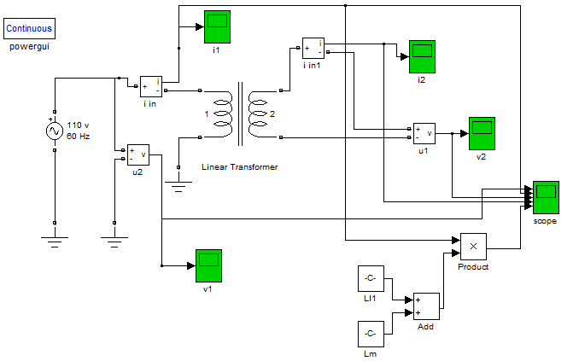

Results:

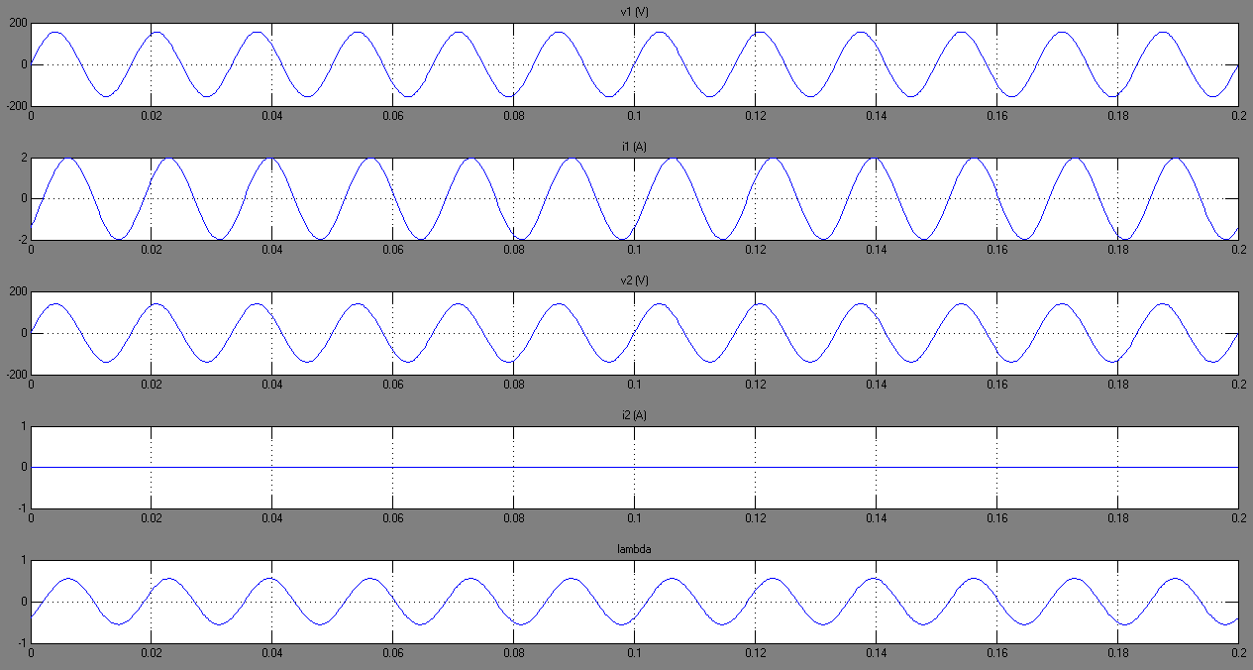

1. Short-circuit condition without saturation:

Circuit:

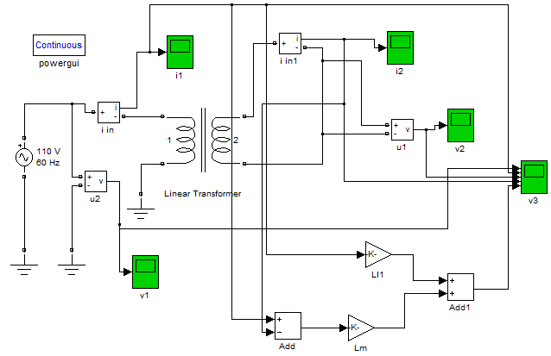

Results:

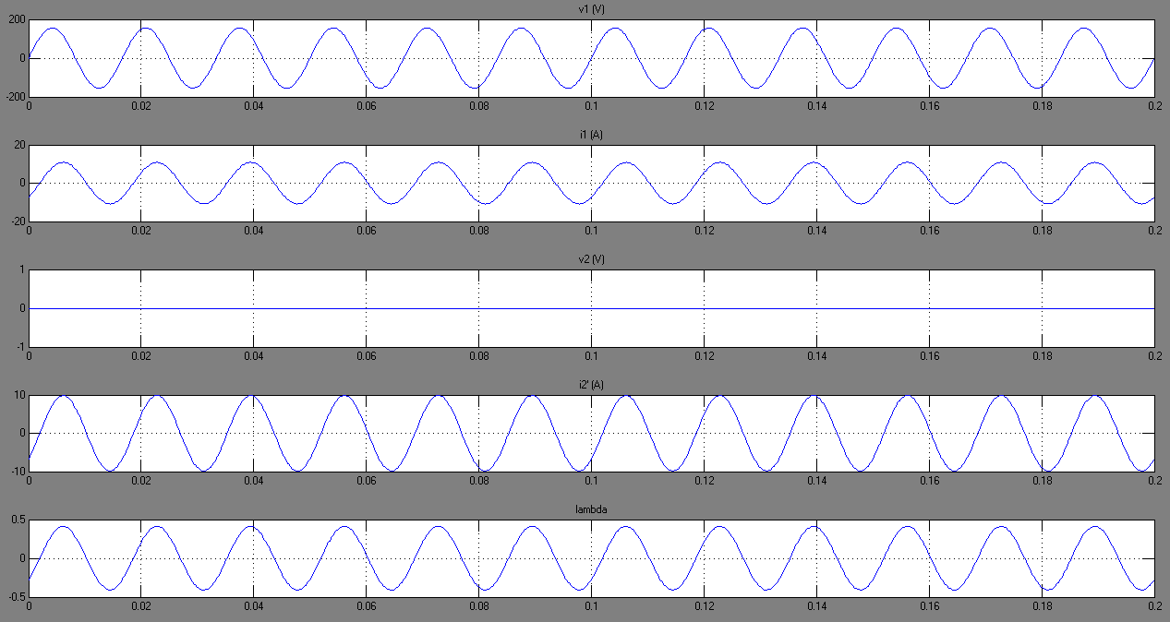

1. Open-circuit condition with saturation:

Circuit:

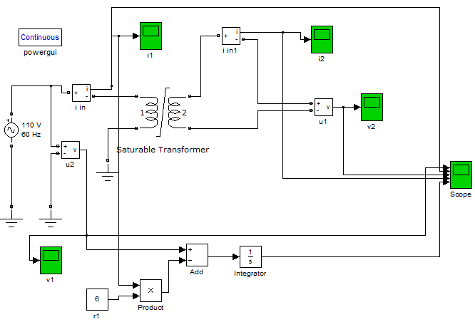

Results:

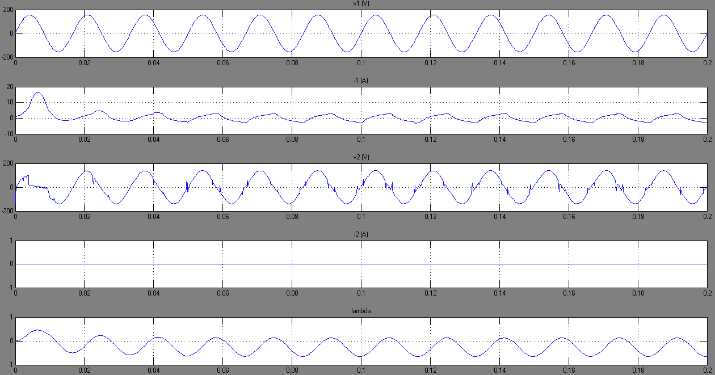

1. Short-circuit condition with saturation:

The following results show that saturation does not occur in short-circuit condition

Circuit:

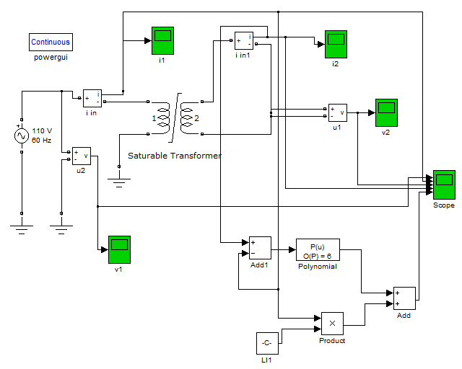

Results:

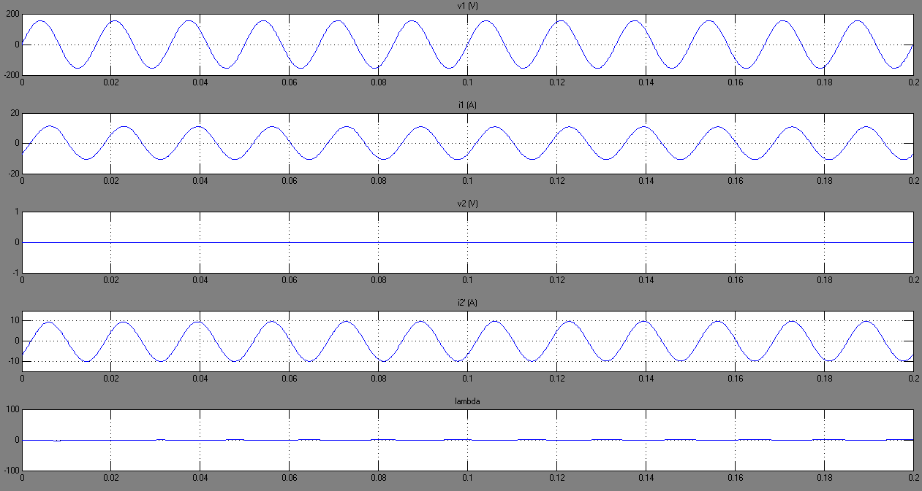

**Conclusion:**

The presented simulation models in this report of transformer tests performed to obtain equivalent circuit parameter. Simulation results by MATLAB and Simulink are compared with those obtained in the book (figure 1.5-1, 1.5-2, 1.5-3 & 1.5-5) and they are matched. This task shows that MATLAB with Simulink/SimPowerSystems toolbox is a good simulation tool to model transformer tests and do the evaluation on steady state and transient characteristics (with or without saturation).